COMPANY LOGIN PAGE

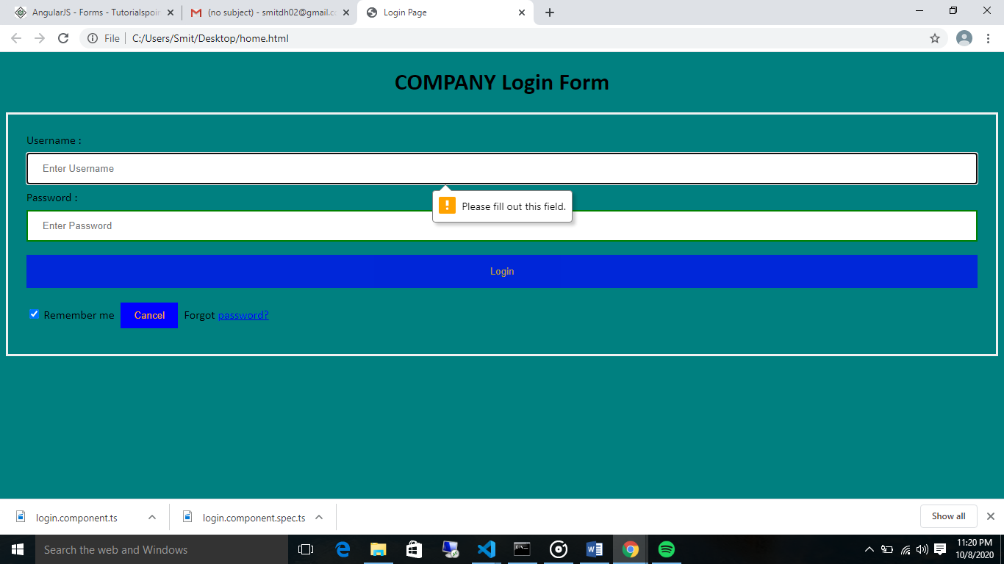

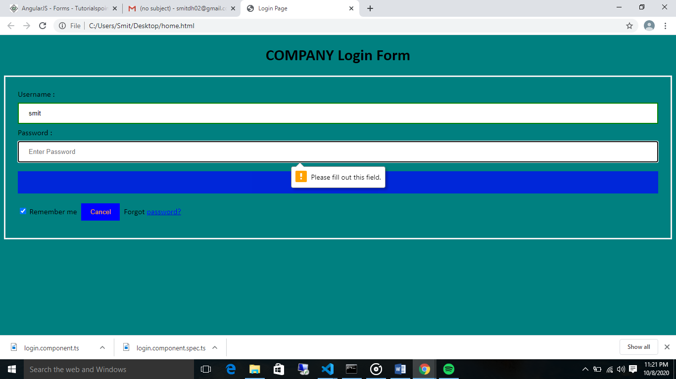

COMPANY LOGIN PAGE MADE USING HTML CSS

JOB SEEKER LOGIN PAGE

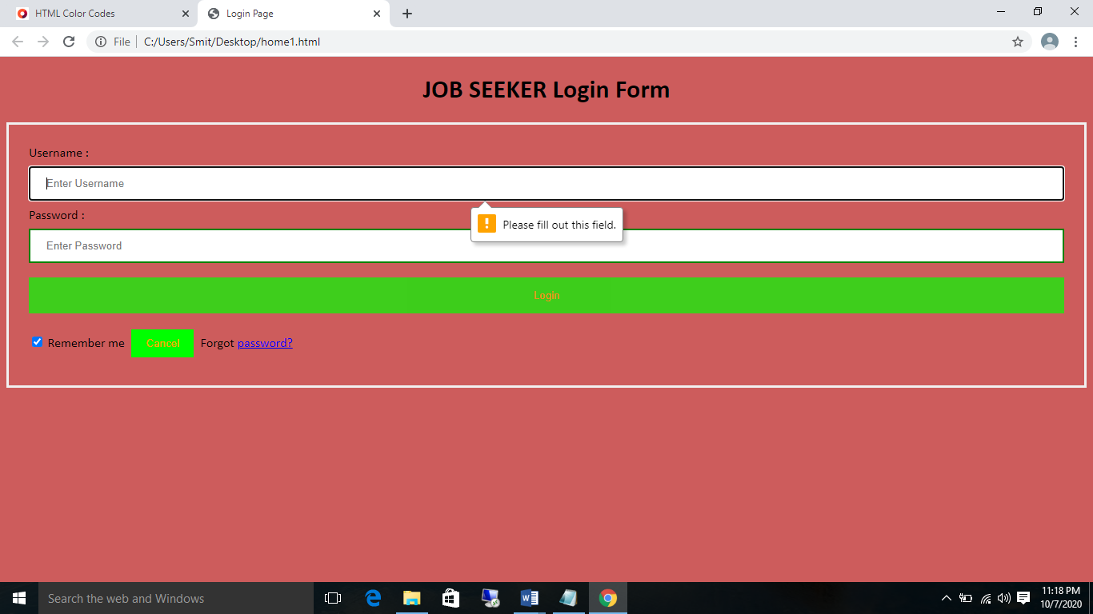

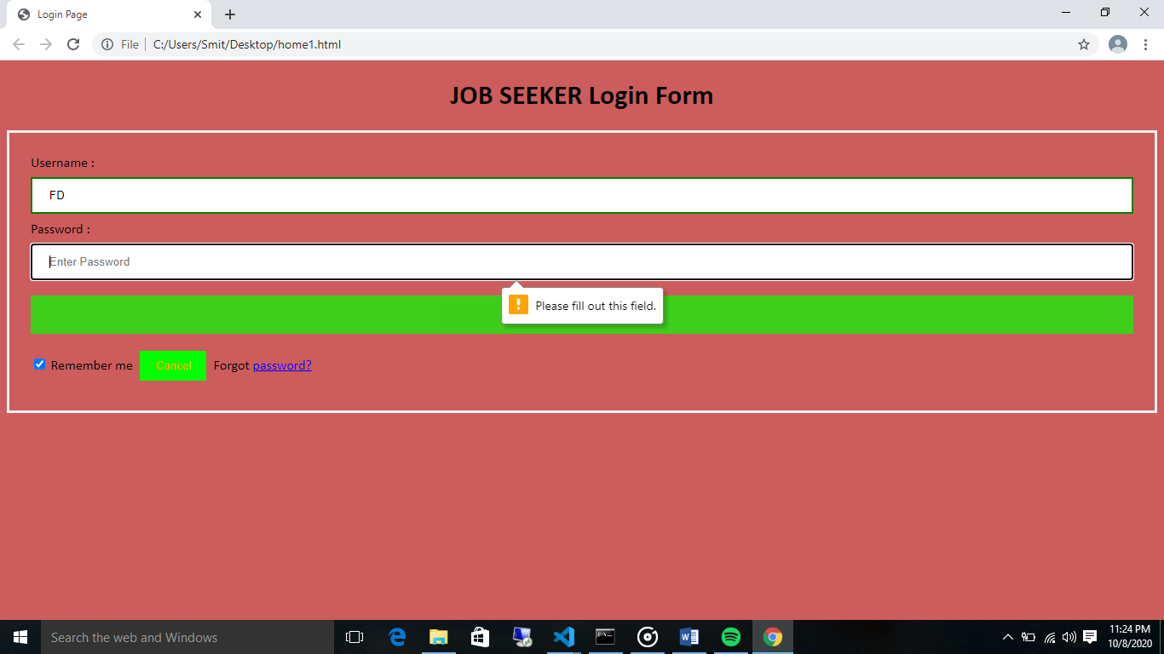

COMPANY LOGIN PAGE MADE USING HTML CSS AND JS.

PERSONAL AND COMPANY SIGN UP PAGE

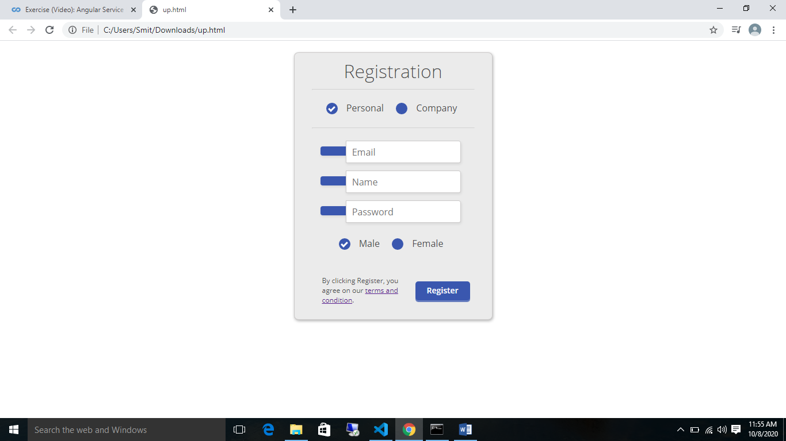

MADE USING HTML CSS AND JS.

DASH BOARD FOR COMPANY LOGIN

CREATE A POSITION

VIEW APPLICANTS

POSITION 1

## **ALL THE DASHBOARDS WILL BE MADE USING HTML CSS ANGULAR AND JS.**

DASHBOARD FOR JOB SEEKER

APPLIED

POSITION 2 COMPANY INFO YRS EXP 3-4

APPLY NOW

POSITION 1 COMPANY INFO YRS EXP 3-4

3-4

DASHBOARD FOR CREATE NEW POSITIONS IN COMPANY LOGIN

JOB DECRIPTION:

EXPERIENCE REQUIRED:

NO OF VACANCY :

COMPANY NAME:

POSITION NAME :

CREATE A POSITION

submit

DASHBOARD FOR VIEW APPLICANTS IN COMPANY LOGIN

NAME : SMIT

EMAIL :SMIT@gmail.com

QUALIFICATION:BSC IT

APPLICANTS DETAILS

POSITION 1